Screenshot 1:

Screenshot 2:

Screenshot 3:

Screenshot 4:

Screenshot 5:

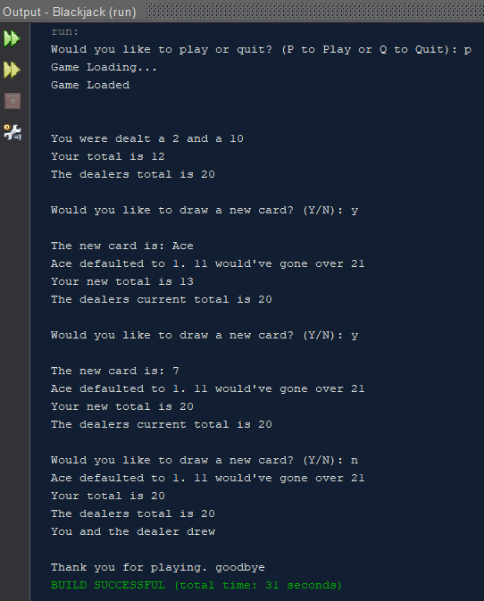

Screenshot 6:

Screenshot 7:

Screenshot 8:

Screenshot 9:

